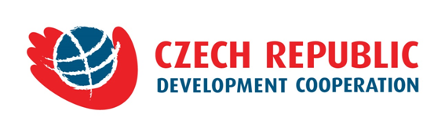
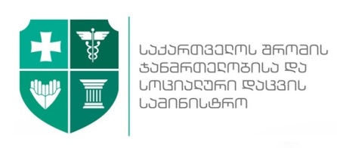

~

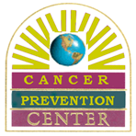
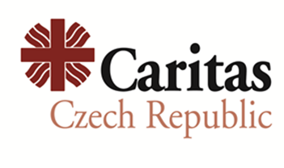


September 9 , 2016, Tbilisi

PRESS RELEASE

In the Frame of Memorandum of Understanding Concluded between Czech Development Agency (CzDA) and Ministry of Labour, Health and Social Affairs (MoLHSA) Conference on

“Promoting Cancer Prevention and Early Detection Measure sin Georgia”
will take place on September 9, 2016

On September 9, 2016, at Zugdidi Municipality City Hall, The Embassy of Czech Republic in Tbilisi, MoLHSA, National Center For Disease Control and Public Health, project implementing parties Caritas Czech Republic in Georgia (CCRG), Cancer Prevention Center (CPC) and NGO Center Tanadgoma in partnership with Zugdidi Municipality Government will hold a conference dedicated to Cancer Prevention and Early Detection issue.

The event aims at drawing attention of the society to the importance of cancer preventive and early detection measures and available state and municipal cancer screening programs in Georgia. The parties will discuss the issue of increasing geographical accessibility to the Cancer Screening State Programs in the region and particularly in Samegrelo-Upper Stvaneti through establishment of Cancer Screening Center in Zugdidi.

At the Conference the organizing parties: CCRG, CPC and Center Tanadgoma will further present the outcomes of the educational project “Oncologic Education of Family Doctors”. The project aims at strengthening the role of primary health workers (family/village doctors) in Cancer Control Strategy through enhancing their education in oncology as well as raising awareness in the population to overcome cancer related stigma.

The Project is being implemented in Samegrelo-Upper Svaneti, Guria and Tbilisi under the Memorandum of Understanding between CzDA and MoLHSA concluded in 2015 (“Support of Early Diagnosis, Prevention and Treatment of Oncological Diseases”).

Conference venue and time: Zugdidi City Hall, Conference Hall, September 9, 2016, at 15:00 – 18:00

For more information about the project contact Caritas Czech Republic in Georgia

- Tamar Kurtanidze, Project Manager (CCRG) tamar.kurtanidze@caritas.cz 593 314504
- Vazha Tavberidze, Communications Manager (CCRG) vazhatavberidze@gmail.com 597576036
ww.charita.cz https://www.facebook.com/CCRGeorgia2015/

General Data: According to WHO, Cancer is one of the leading causes of morbidity and mortality worldwide and its indicator is increasing annually. By official Data, in Georgia in 2015 around 9000 new cancer cases were identified. The effective approach of cancer control is prevention and early detection which includes active engagement of primary health workers in this process as well as education of the population about healthy life-style and importance of early detection, increasing accessibility to cancer screening programs.

Information about the project: Caritas Czech Republic, Caner Prevention Center and NGO Center “Tanadgoma” have been implementing projects on cancer prevention and early detection since 2010. Current project “Oncologic Education of Family Doctors” is based on above mentioned approach: on one hand, promoting role of primary health sector in the cancer control strategy and on another hand, raising awareness of the population on this issue.

